**COLLAGE BUSINESS EDUCATION**

**DODOMA COMPAS**

**DEPARTMENT OF INFORMATION AND COMMUNICATION TECHNOLOGY**

**OF BACHELOR DEGREE IN INFORMATION TECHNOLOGY (BIT)**

**LECTURES NAME:ATUPELE CAIRO**

**STUDENT NAME: MOSES NDAILE**

**REGISTRATION NUMBER: 03.6172.02.02.2022**

**COURSE NAME :BIT2**

**NAME OF THE PROJECT: MOEZON ECOMMERCE WEBSITE**

**SUBMISSION DATE: JAN/28/2025**

**E-commerce ONLINE MARKET MANAGEMENT SYSTEM REPORT**

**introduction**

* An e-commerce website is an online store where customers can browse, select, and purchase products or services over the internet.   **Core Function:** It facilitates the entire buying and selling process online, from product display and selection to payment processing and order fulfillment.

**Examples of E-commerce Websites:**

* **Amazon:** A massive online marketplace selling a vast array of products.
* **eBay:** An online auction and marketplace platform.
* **Shopify:** An e-commerce platform that allows businesses to create their own online stores.
* **Etsy:** A marketplace for handmade and vintage goods.

**Benefits of E-commerce:**

* **Increased Reach:** E-commerce websites can reach a global audience beyond geographical limitations.
* **24/7 Availability:** Online stores are accessible 24/7, allowing customers to shop at their convenience.
* **Lower Overhead Costs:** Compared to physical stores, e-commerce businesses often have lower overhead costs (e.g., rent, utilities).
* **Improved Customer Experience:** E-commerce websites can offer personalized experiences, targeted recommendations, and convenient shopping features.
* **Data-Driven Insights:** E-commerce platforms provide valuable data on customer behavior, which can be used to improve marketing strategies and business decisions.
* **Key Features:**
  + **Product Catalog:** A comprehensive list of products with detailed descriptions, images, and pricing.
  + **Search and Filtering:** Enables customers to easily find specific products using search bars and filters (e.g., size, color, price range).
  + **Shopping Cart:** Allows customers to temporarily store selected items before making a purchase.
  + **Secure Checkout:** Provides a secure payment gateway for processing online transactions (e.g., credit cards, debit cards, digital wallets).
  + **Order Tracking:** Enables customers to track the status of their orders from placement to delivery.
  + **Customer Accounts:** Allows customers to create accounts for personalized experiences, order history, and easier checkout.
  + **Customer Support:** Offers various channels for customer support (e.g., FAQs, live chat, email).

Based on the key part I made an online market named Moezon online market shop I made it by the help of the codes in the beloe diagrams

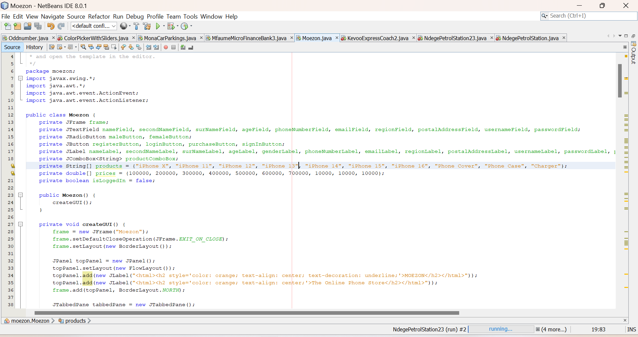  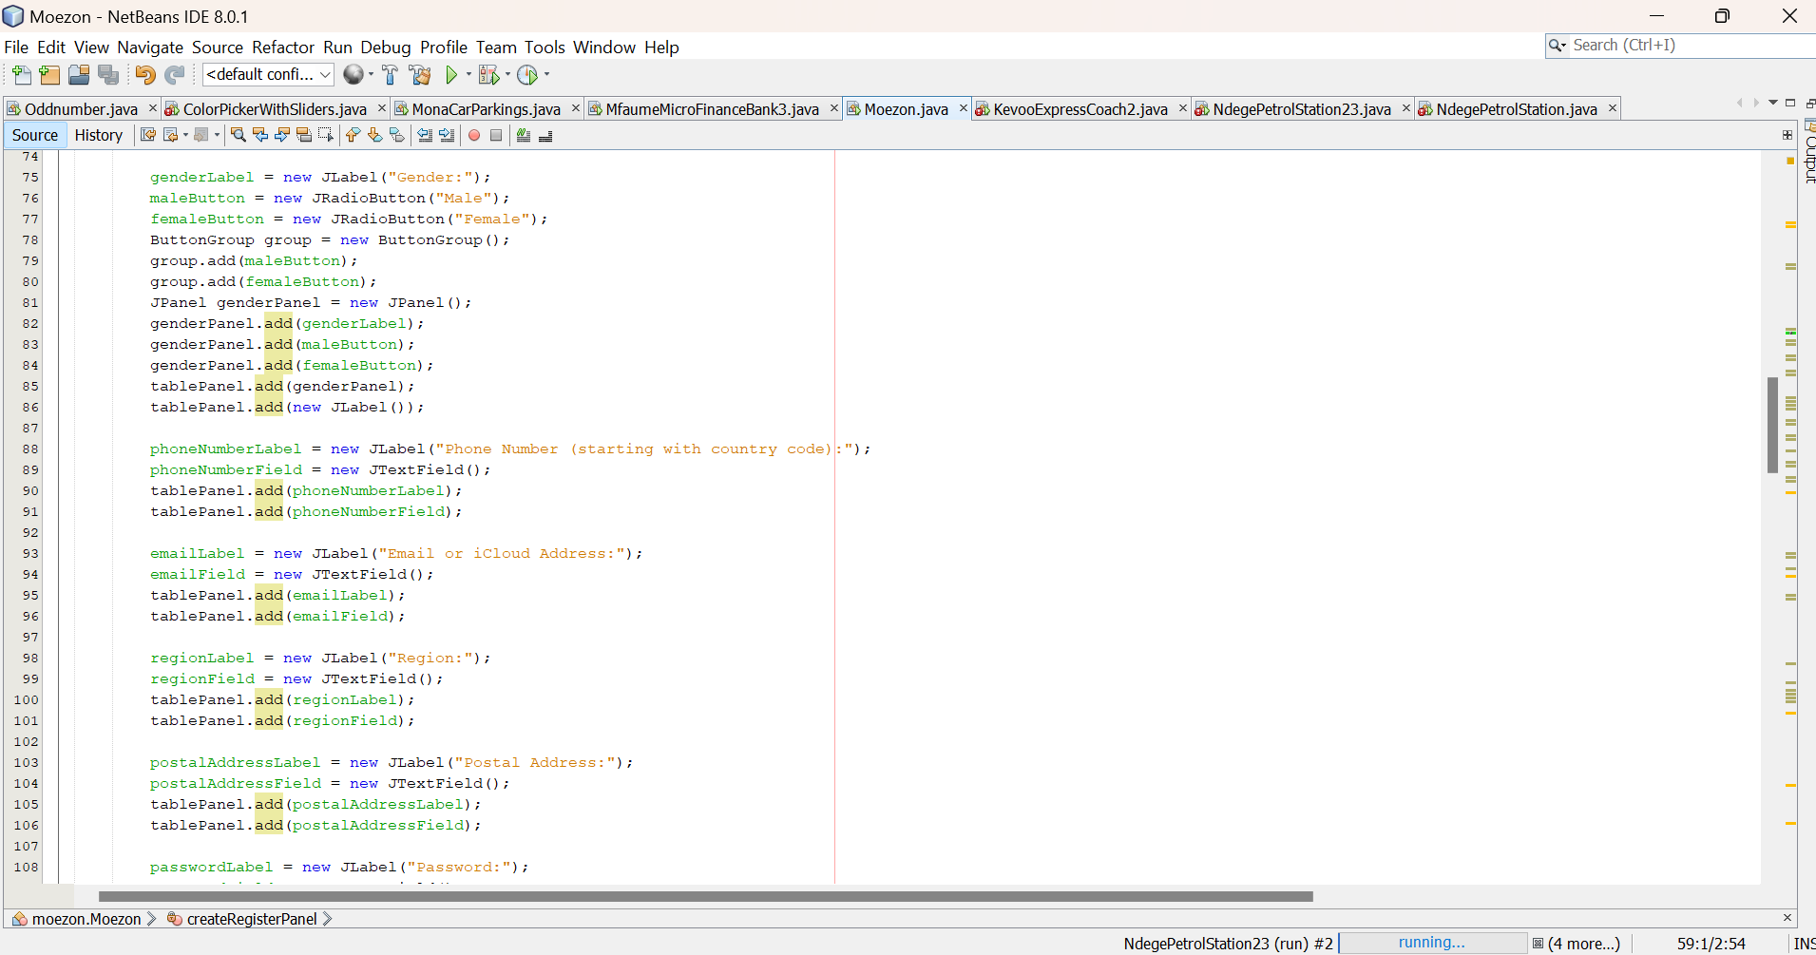 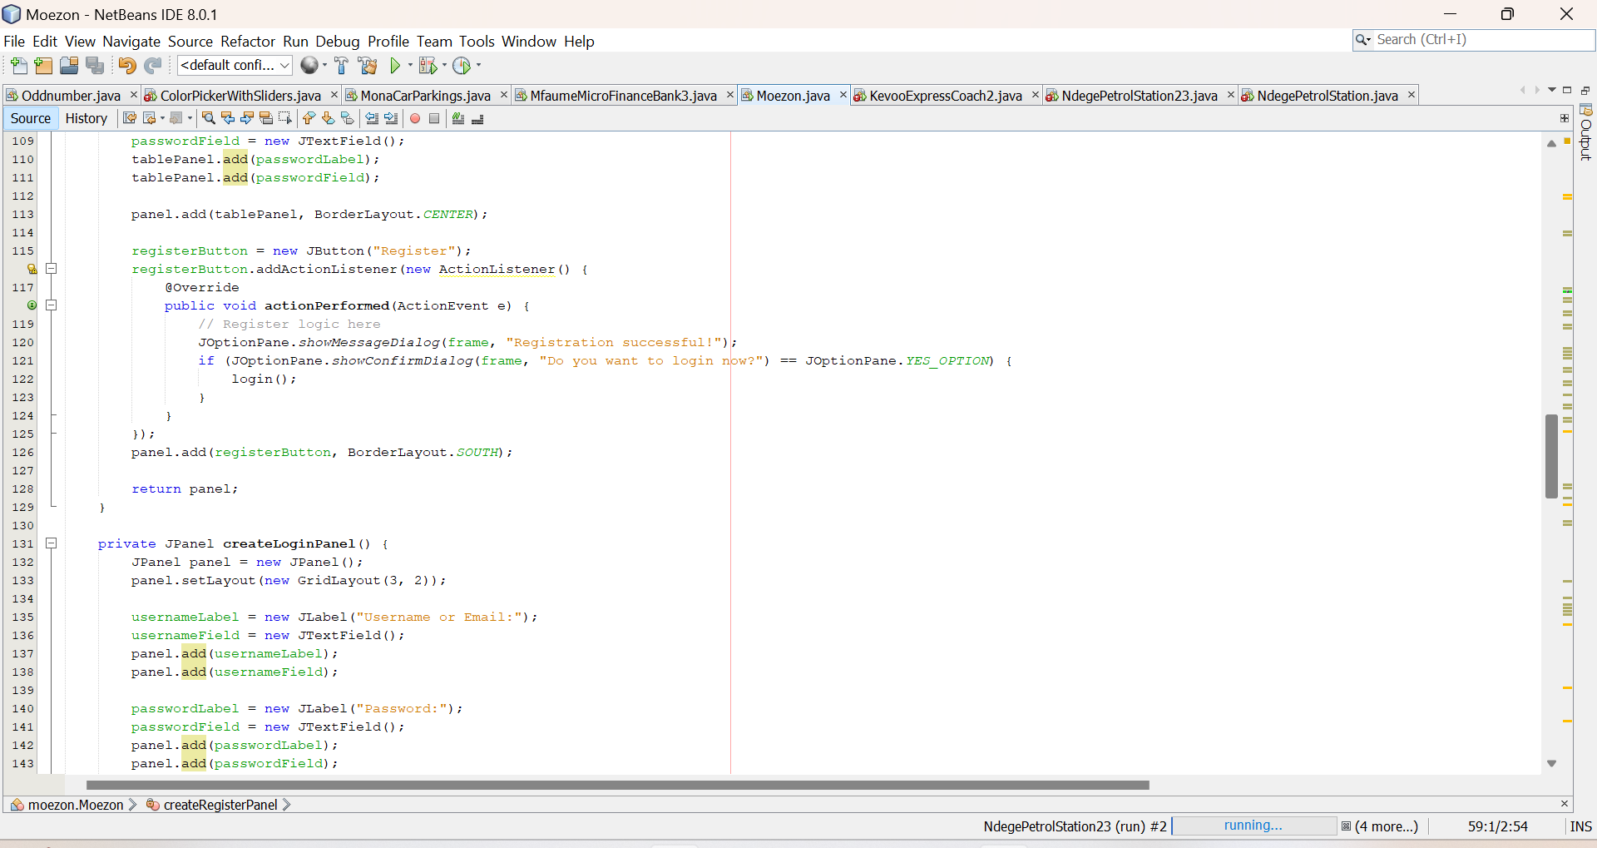 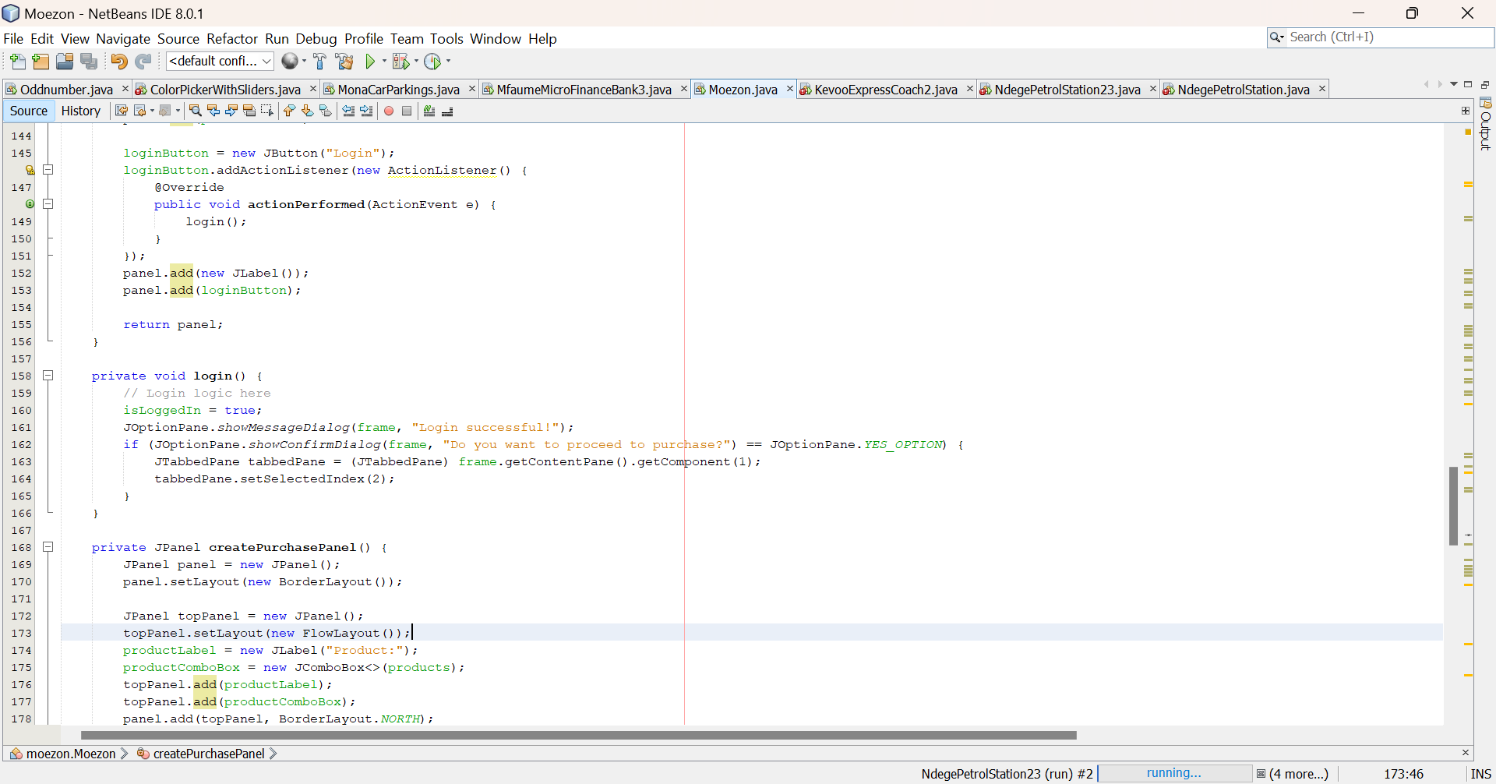 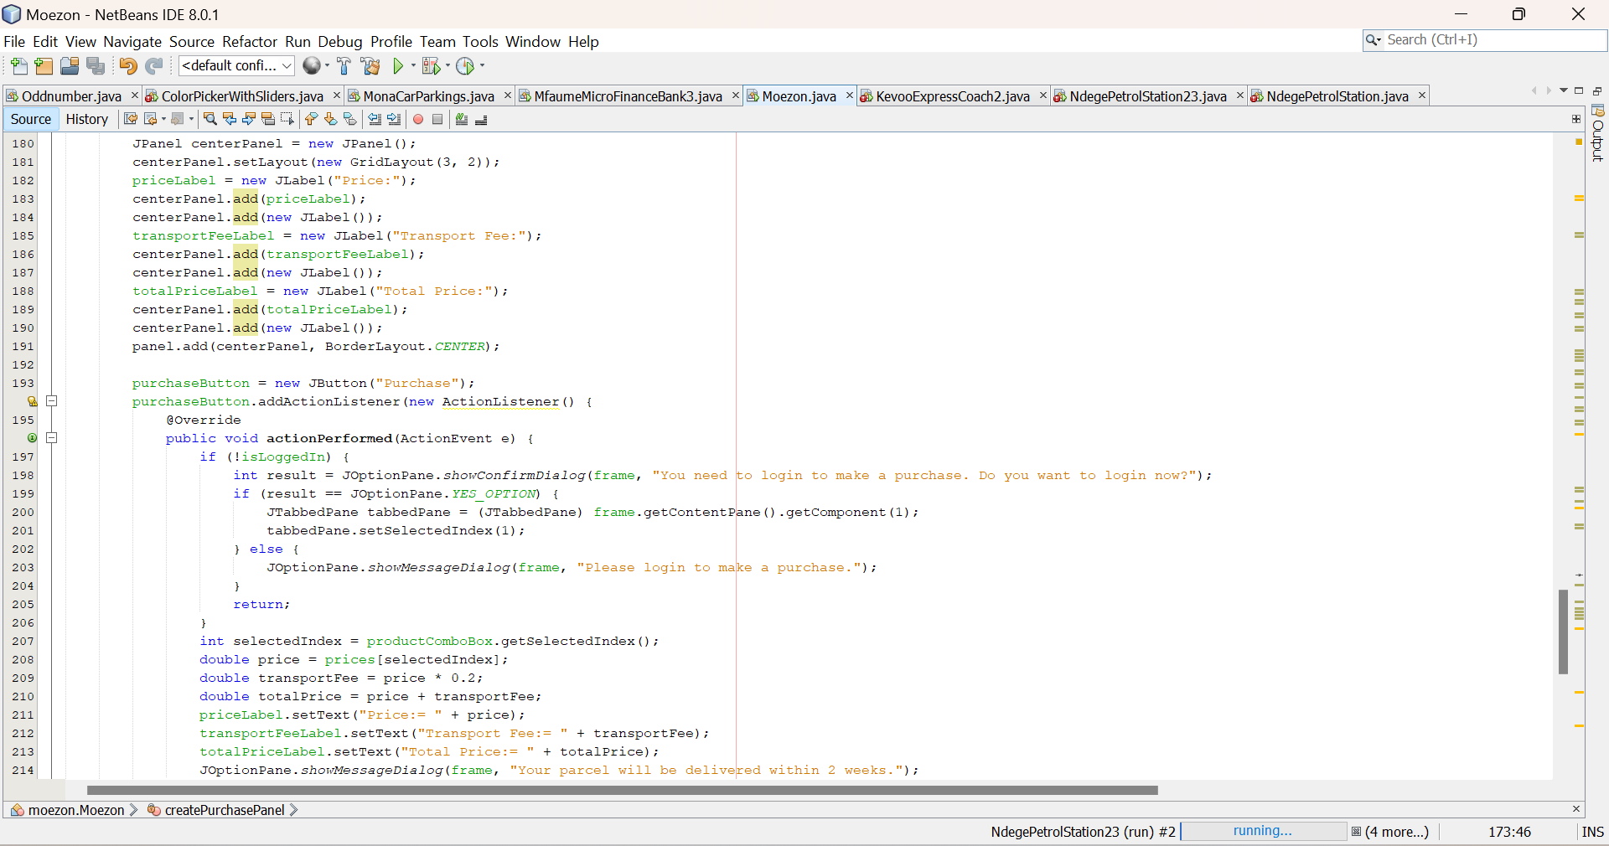 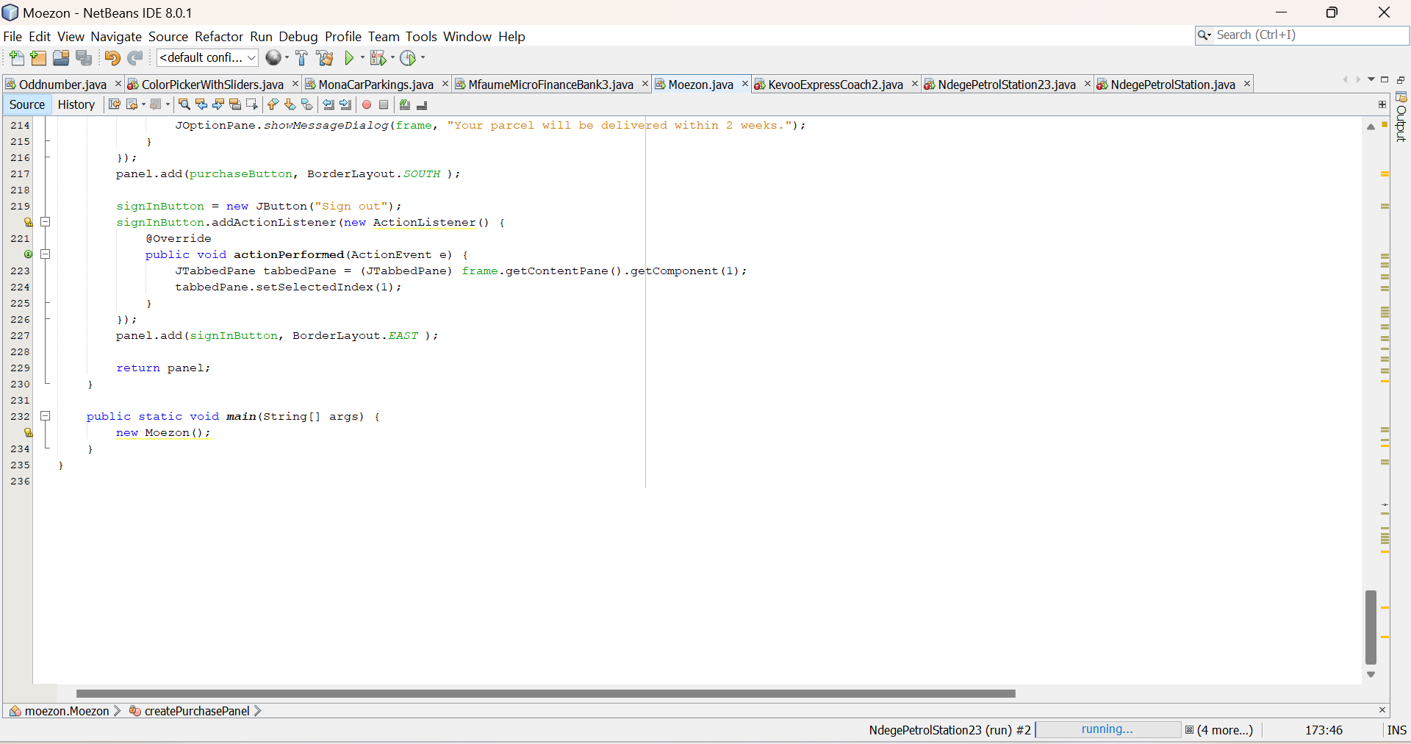

The figures above were the code I used to make my ecommerce that allowed a user to register as the figure below shows 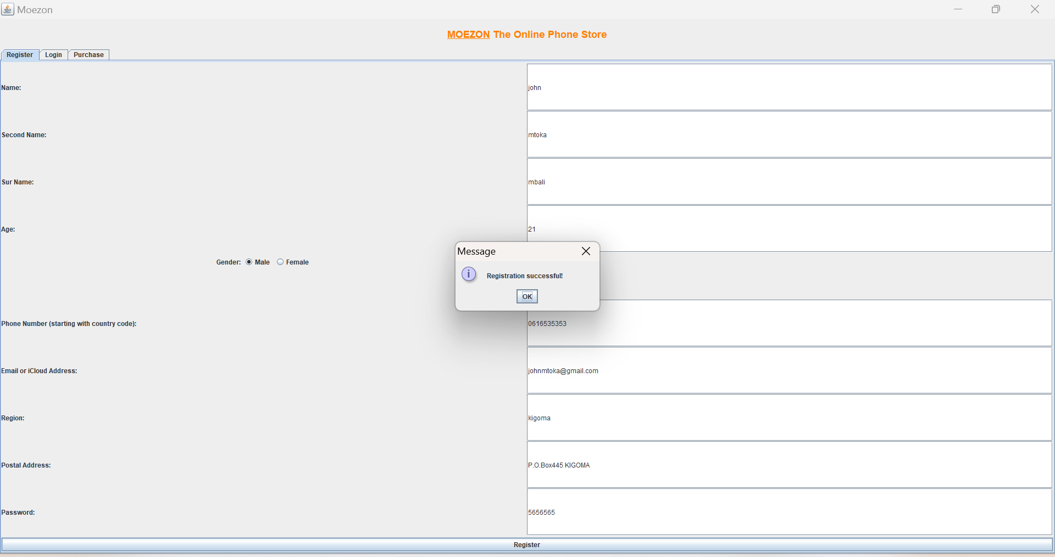

Also the programe had the page for those who are having an account and they have to login 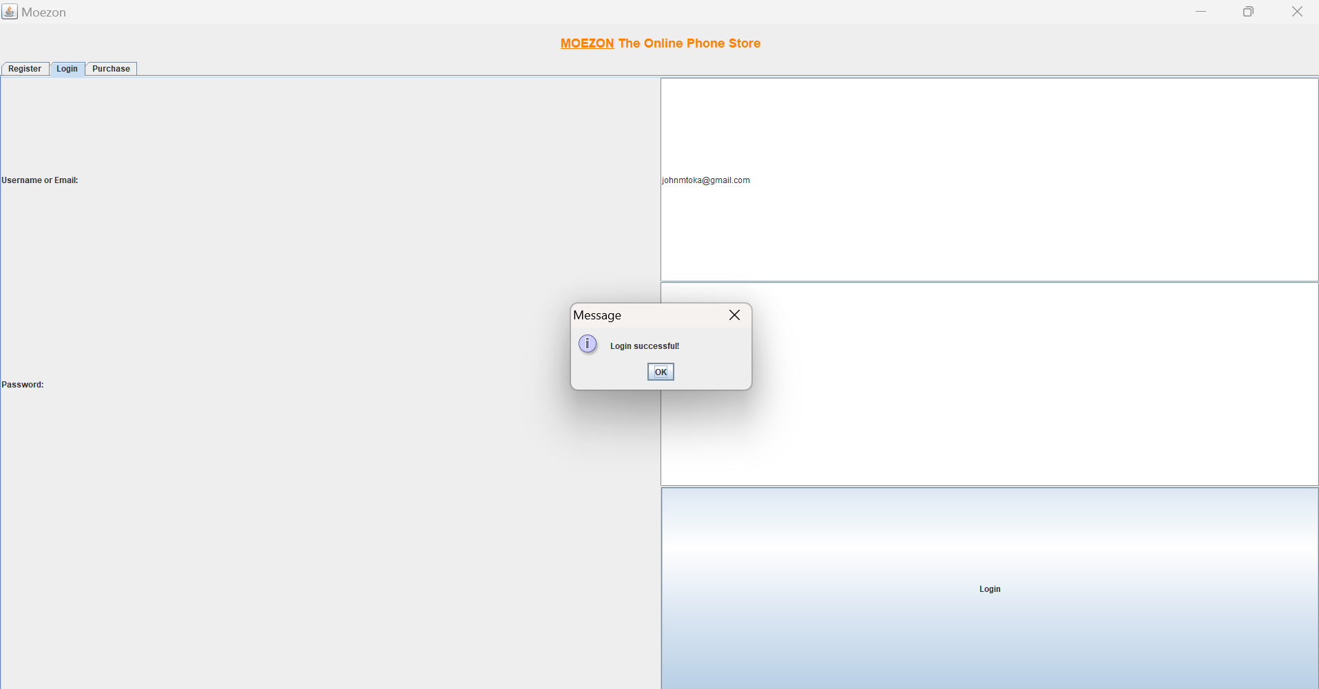

Finally the page for purchses of the items that also will tell how long will the item deliver to your place after placing the order 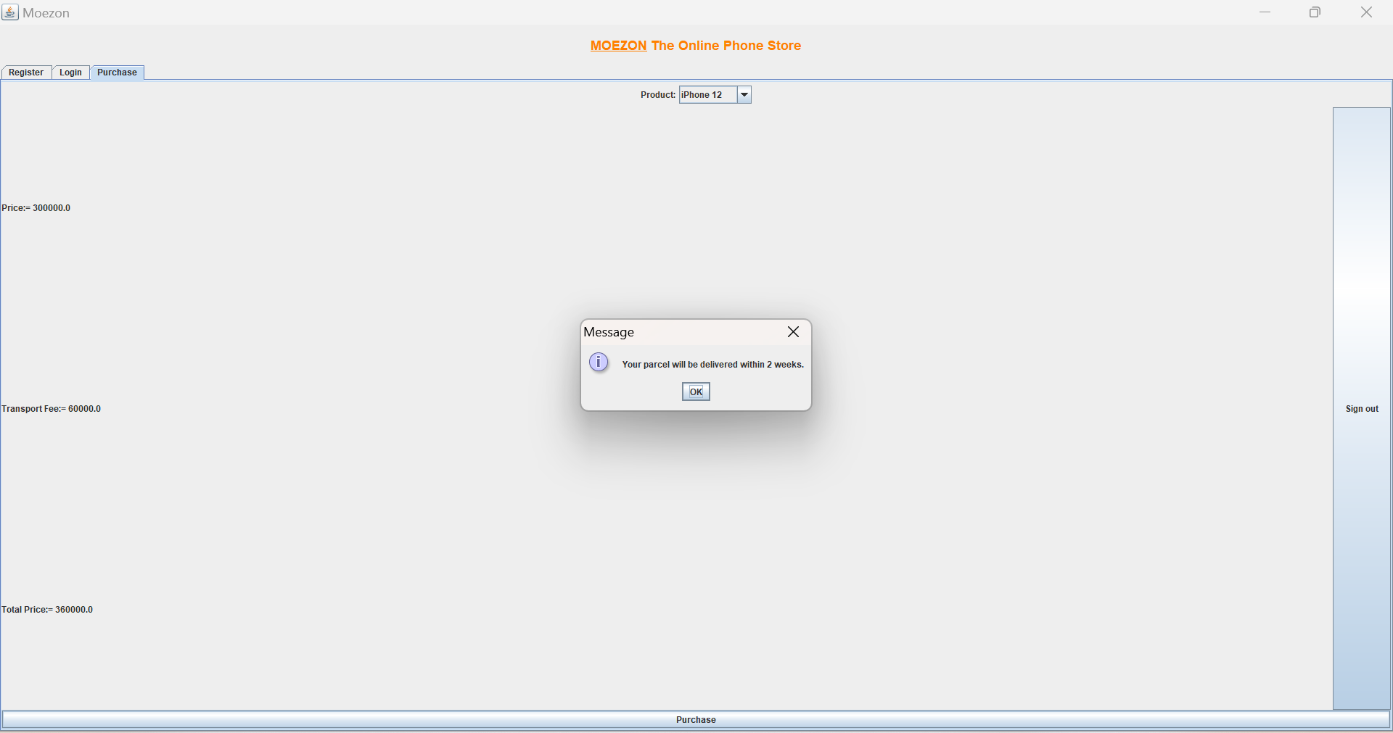

Then the programe will allow you to sign out or place another order again.hence Moezon online market was successful

But it had some challenges as shown below

E-commerce, while offering numerous advantages, faces several significant challenges:

**1. Intense Competition:**

* **Market Saturation:** The e-commerce space is highly competitive, with numerous established players and new entrants constantly emerging.
* **Price Wars:** Competition often leads to price wars, making it difficult for businesses to maintain profitability.
* **Differentiation:** Standing out from the crowd requires unique selling propositions (USPs) and a strong brand identity.

**2. Cyber Security Threats:**

* **Data Breaches:** Customer data, including financial and personal information, is highly valuable to cybercriminals.
* **Fraudulent Activities:** E-commerce businesses are vulnerable to fraud, such as credit card fraud, account hacking, and identity theft.
* **Data Privacy Concerns:** Complying with data privacy regulations (e.g., GDPR, CCPA) is crucial but can be complex and costly.

**3. Logistics and Fulfillment Challenges:**

* **Shipping Costs:** High shipping costs can significantly impact profitability, especially for smaller businesses.
* **Delivery Delays:** Ensuring timely and reliable delivery is crucial for customer satisfaction, but logistics can be complex and unpredictable.
* **Returns and Refunds:** Managing returns and refunds efficiently can be costly and time-consuming.

**4. Customer Acquisition and Retention:**

* **High Customer Acquisition Costs:** Acquiring new customers through online advertising and marketing can be expensive.
* **High Cart Abandonment Rates:** Many customers abandon their shopping carts before completing a purchase, leading to lost revenue.
* **Building Customer Loyalty:** Retaining existing customers is crucial for long-term success, but building loyalty in a competitive market can be challenging.

**5. Technological Challenges:**

* **Maintaining a Secure and Reliable Website:** Ensuring website uptime, security, and performance is critical for a successful e-commerce business.
* **Keeping Up with Technological Advancements:** E-commerce technology is constantly evolving, requiring businesses to adapt and invest in new technologies.
* **Integrating with Third-Party Platforms:** Integrating with payment gateways, shipping providers, and other third-party platforms can be complex.

**6. Changing Consumer Behavior:**

* **Evolving Customer Expectations:** Customers have increasingly high expectations for online shopping experiences, including fast shipping, personalized recommendations, and seamless customer service.
* **Social Media Influence:** Social media platforms play a significant role in influencing purchasing decisions, making it crucial for businesses to maintain a strong social media presence.
* **The Rise of Mobile Commerce:** The increasing use of mobile devices for online shopping requires businesses to optimize their websites and mobile apps for a mobile-first experience.

**7. International E-commerce Challenges:**

* **Cross-border Shipping and Logistics:** International shipping can be complex and expensive, with challenges such as customs regulations, currency fluctuations, and international payment processing.
* **Language and Cultural Barriers:** Communicating with customers in different languages and cultures can be challenging.
* **International Regulations:** Navigating the legal and regulatory landscape of different countries can be complex.

**REFERENCE.**

* **"Contagious: Why Things Catch On" by Jonah Berger:** Explores the psychology of virality and how to create marketing messages that spread like wildfire.
* **"Crossing the Chasm" by Geoffrey A. Moore:** Explains how to successfully transition a product or service from early adopters to the mass market.
* **"Influence: The Psychology of Persuasion" by Robert B. Cialdini:** A classic that explores the principles of persuasion and how to influence consumer behavior.